NAME Treepat Chantaurai

DATE 15 November 2021 Section J

**Report Sheet for Experiment 10: Measuring the earths magnetic field**

Abstract

In this experiment, the concept of electromagnetic induction was applied in this experiment with a transformer of different magnetic core shape and different turn number of secondary coils. The core acts as a medium to let the magnetic flux pass through, reflected by the worst output voltage when it is absent of core, and an increasing trend of output voltage when more connecting and better shape of core is used. Moreover, when number of secondary coil turn is increased, the output voltage will be linearly increased as the theory suggests.

Introduction and Theoretical Background

Faraday’s law states that a change in magnetic flux will generate electromotive force which the magnetic flux can be written as the dot product of magnetic field and the surface area. Moreover, the electromotive force(emf) can be expressed as the negative of time-derivative of such magnetic flux.

Transformer is a device which can change high voltage current to low voltage ones and vice versa. Its underlying mechanism is composed of two conducting coils called primary and secondary ones in which these two coils have different turns. Wrapped around the same iron core, the change in magnetic flux sensed by two coil is the same and their voltages can be written as a function of number of turns and the time-derivative of magnetic flux as follows:

$$V_{1}= -N_{1}\frac{∆ϕ_{B}}{∆t}, { V}_{2}= -N_{2}\frac{∆ϕ_{B}}{∆t}$$

With an assumption of an ideal transformer without any power loss and power equals potential times current, the relationship between primary current and voltage to those of secondary coil can be derived as follow:

$$V_{2}= \frac{N_{2}}{N_{1}}V_{1} , I_{2}= \frac{N_{1}}{N_{2}}I_{1}$$

Methods

Part 1 – Role of the core

1. Set the voltage of power supply to 3V and turn off
2. Place 400 turns coils side by side without a chord, connect both to power supply, then turn on
3. Measure both voltages
4. Have magnetic cores sliding into holes of the coil, including, U core, I core and U+I core and repeat step 2 and 3

Part 2 – Voltage Conversion

1. Set the voltage of power supply to 1 V and turn off
2. Put 400-turn coils in U+I core, connect to power supple, then turn on
3. Measure both voltages
4. Repeat step 5-7 with power supply’s voltage of 2,3,4,5 V
5. Repeat step 5-8 with secondary coil having 1600 and 3200 turns

Results

|  |  |
| --- | --- |
| current range | 3 A |
| voltage range | 30 V |
| coil turns | 400-400 |
| initial voltage | 3 V |

Table 1 summarizes parameters used in the experiment Part 1

|  |  |  |
| --- | --- | --- |
| type of core | primary voltage (V) | secondary voltage (V) |
| without core | 1.8 V | 0.093 V |
| I core | 2.5 V | 1.238 V |
| U core | 3.1 V | 1.208 V |
| U/I core | 3.1 V | 2.943 V |

Table 2 summarizes primary and secondary voltages measured with different cores

Figure 1 depicts the secondary and primary voltage linear relationship which an increase in the secondary turns increases the slope of the graph

|  |  |
| --- | --- |
| current range | 3 A |
| voltage range | 30 V |
| coil turns | 400-400, 400-1600- 400-3200 |
| initial voltage | 1 V, 2 V, 3 V, 4 V, 5 V |
| Type of core | U + I |

Table 3 summarizes parameters used in the experiment Part 2

|  |  |  |  |
| --- | --- | --- | --- |
|  | 400-400 turns | 400-1600 turns | 400-3200 turns |
| Fitted equation | $$y=AX+B$$ | | |
| A | 0.889 | 3.584 | 7.123 |
| B | 0.169 | 0.551 | 1.140 |
| R2 | 0.9995 | 0.9995 | 0.9998 |

Table 4 summarizes parameters used to fit linear line in Figure 2

Figure 2 depicts the relationship between the ratio between secondary and primary voltage and the number of secondary coils turns. Increasing number of the secondary coil turn will linearly increase the output voltage from the transformer. The fitting equation is y = 0.0022x – 0.0085 ; R2 = 1

Discussion

From the experiment, the role of the magnetic core can be observed. When having an equal number of coils turn on the primary and secondary coil, the input and output voltages are expected to be equal as well. However, this does not go along well with the experiment. While having no core or I core or U core, the out secondary voltage drops dramatically. This is because the emf and therefore magnetic flux is not properly induced in those shapes (thus, it is the worst when there is no medium at all). The combination between U and I core yields the best transformation of $\frac{2.943-3.1}{3.1}x100$ = -5.06%. This is because the magnetic flux can be induced through the medium of magnetic U+I core, resulting in a less loss of energy as depicted in Figure 3.

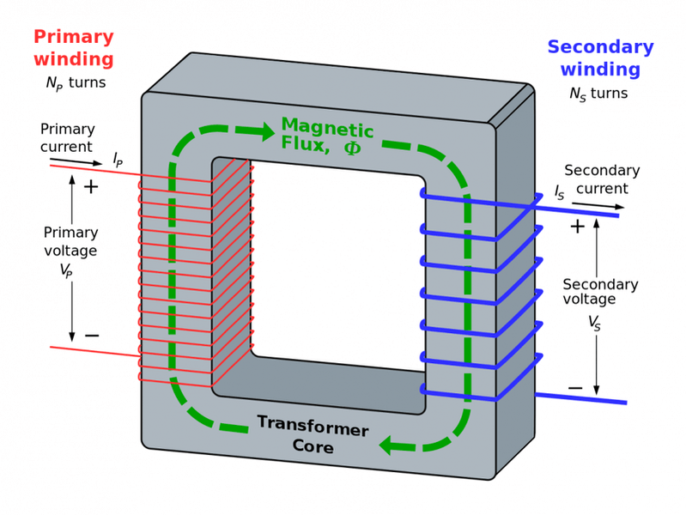

Figure 3 depicts the magnetic flux direction in a U+I transformer

Furthermore, effect number of secondary coils turns on the secondary voltage in a U+I transformer is investigated. The results agree with what the theory suggests. The secondary and primary voltage have a linear relationship which an increase in the secondary turns increases the slope of the graph(ratio between of input and output voltage).

Conclusion

In conclusion, the concept of electromagnetic induction was applied in this experiment with a transformer of different magnetic core shape and different turn number of secondary coils. The core acts as a medium to let the magnetic flux pass through, reflected by the worst output voltage when it is absent of core, and an increasing trend of output voltage when more connecting and better shape of core is used. Moreover, when number of secondary coil turn is increased, the output voltage will be linearly increased as the theory suggests.

Reference

1. Lab manual titled “**Ch10.** **Measuring the earths magnetic field”**from Department of Physics on KLMS
2. Goodphy. (2017, February 19). *Magnetic flux and current directions of Transformer*. Retrieved November 19, 2021, from https://www.physicsforums.com/threads/magnetic-flux-and-current-directions-of-transformer.904621/.